Business Presentations: Essentials



Content
1 Structure of a Speech page 3
- 3 parts of a speech
2 Model Speech 1 page 4
- Self-introduction
3 Delivery Skills page 6
- Eye contact, gestures, voice
4 How to say it page 8
- Expressions for speeches
5 Logic Tree Notes page 9
- Organizing your ideas
6 Model Speech 2 page 12
- Company introduction
7 Quick Speech page 14
- Speeches in 15 minutes or less
8 Language for Chairing page 15
- How to introduce the speaker



1: Structure of a Speech
- Speeches have three important parts. Each part has a specific purpose.
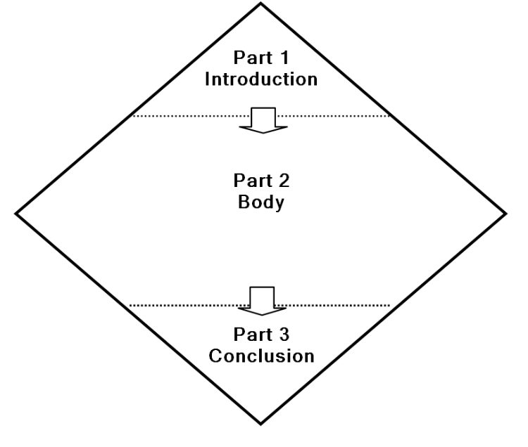

Part 1 – Introduction: Say what you are going to say.
This is the foundation of your speech.
- Greet your audience. Introduce your theme and your main points.
- Get your audience interested!
Part 2 – Body: Say what you want to say.
This is the main part of your speech.
- Tell your audience everything you want them to know.
- You must select what you say: you cannot say everything about your theme – just the most important ideas linked to your message.
- Keep your audience interested!
Part 3 – Conclusion: Say what you said. Deliver your message.
This is the wrap up – make a strong finish.
- Review your theme and your main points.
- Do not introduce any new ideas or new information.
Deliver your message clearly: it is a vital part of your conclusion.
- Clearly express your opinion or state what action is needed.
- Leave your audience thinking about your message!

2: Model Speech 1
- Model Speech
Below is a model self-introductory speech. It is very short however, it follows the basic speech structure of introduction, body, and conclusion. Read the speech carefully.

Background: Hiroshi Tanaka works for The Nippon Taiyo Bank, a large bank based in Tokyo with branches all over Japan. Below is the self-introductory speech he gave at a training program.

Notes | Text
1. Introduction  Greetings & Courtesies | Thank you, Mr./Ms (Instructor’s name). Good afternoon everyone. It’s a pleasure to be here. As Mr. / Ms (Instructor’s name) said, my name is Hiroshi Tanaka. I’d like to tell you a little about myself and why I decided to join the Nippon Taiyo Bank.
2. Body  My background & interests+ comments | I was born in Hokkaido but I grew up and went to school in Kyoto. In high school I always liked mathematics and the sciences, so when I went to university I decided to study physics. I also took some courses in economics which were very interesting.
Why I joined NTB | Since I enjoyed both physics and economics I decided I wanted to combine them in my career, so I looked for a job in banking. That’s why I decided to join the Nippon Taiyo Bank.
General statement  Introduce my goal at NTB  +  concluding comment | In my career at NTB I know I will work in many different departments, but I really want to use my degree in physics to develop useful new quantitative tools to analyze market trends and risk. This kind of analysis is very important for the bank and for the businesses that it serves. I think this will be very interesting and useful work. This is my personal goal for my career at the Nippon Taiyo Bank.
3. Conclusion  Courtesies  Closing courtesy | I am very happy to be here today and I am glad to be working with you all.  Thank you very much.

- Exercise
Use the model above to write an introduction of yourself. Write your speech on the next page or write it on your computer and print it out. (Length: 90 seconds)
Practice the delivery of your self-introduction using the delivery skills in Unit 3.
- Your Self-introductory Speech

3: Delivery Skills
- Good delivery skills are essential for a good presentation.
Good delivery skills build your confidence and win the attention of your audience.
- Your teacher will model each of these skills for you one-by-one.
- Stand up and practice the skills with your teacher until they are easy to do.

Eye Contact
Voice
Clothing
Gestures
Notes
Posture

Speak to your audience. Deliver your message.

- Voice
Your voice is your most important delivery tool.
A clear strong voice delivers your message to your audience. If they cannot hear you they will not receive your message.
- Speak clearly, smoothly, and without hesitation.
- Don't rush or speak too quickly.
Emphasize the important words and phrases.
- Eliminate the pauses and Ummmms.
- Eye Contact
Eye contact connects the speaker and the audience.
- Look at your audience, not at your notes.
- Look at the whole audience. Move your head so you can make eye contact with everyone.
- Notes
Hold your notes just above your waist where you can easily see them and look at your audience.
- Hold the page in the middle so it won’t fold over.
- Don’t move your notes up and down: it’s very distracting.
- Don't put your notes on a table or lectern – If you're looking down at your notes, you can't look at your audience.
- Posture
Good posture helps your breathing and makes you appear more confident.
- Stand straight with your feet slightly apart and your weight evenly on both feet.
- Don't lean on the table or lectern – look at your audience.
- Gestures
There are three positions for your other hand: by your side, behind your back, or gesturing.
Gesturing is the best thing to do with your free hand:
- Gestures attract your audience’s attention and emphasize important points.
- Gestures should be simple, firm and clear.
- Gestures and eye contact go together. When you gesture, look at your audience. If you are not looking at your audience, do not gesture.
- When you count (1st, 2nd, 3rd), gesture with one finger, two fingers, three fingers.
- Don’t count with your fingers if you say, "My next point is…" or "My last point is…"
- Don't scratch your face or play with your hair!
- Don’t cover your face with your hand if you adjust your glasses.
- Clothing – Neatness counts!
Make sure your clothing is appropriate for the situation and then wear it neatly.
- Messy clothing and hair will distract your audience from your message.
- Before you speak make sure your clothing is neat: check your tie, your jacket collar, and your hair.
- Tips for Effective Speaking
- Starting Your Speech
Your speech begins when you are called to speak.
Before you speak, pause, look at your audience, and get their attention. Take a deep breath and begin.
- Speak to Your Audience
If you memorize parts of your speech, you can look at your audience. Memorize –
- your greetings
- your introduction
- the beginning of each main point
- your conclusion and closing thoughts
- Speak Clearly and with Passion
Let your audience know that you care about your topic: Speak with energy and enthusiasm in your voice.
- Emphasize important words with your voice and with gestures.
- Pause slightly before and after names, dates, numbers, and important words.
For example: “In^2012,^Protech^sold^187,000 units of ^PX-Y40.”

4: How to say it
- Flag Expressions
 | - Flag Expressions are special expressions that introduce each step in the structure of your speech.  - Flag Expressions are like a tour guide’s flag: everyone can follow the guide’s flag and not get lost. If there is no flag the guide is too hard to follow.
- Memorize and use the Flag Expressions. They will help you organize your information and ideas, and express yourself clearly.

Part | Purpose | Flag Expressions
1  Introduction | - Appreciate the introduction | Thank you for the introduction, (Mr. Chairman).
 | - Greet the audience | Good evening, everybody.
 | - Give your theme | Today, I am going to tell you about …
 | - Give your main points | I have three main points.
 |  | First, |  | (Never say At first)
 |  | Second, |  | I will talk about…
 |  | Third,
2  Body | - Start the body | Let me begin with my first point.
 | - Second point | Now, I’ll move on to my second point.
 | - Third point | Now, I will tell you my third point.
3  Conclusion | - Review | In conclusion, let me review my main points.
 |  |  | First,
 |  |  | Then, |  | I talked about….
 |  |  | Finally,
 | - Your Message | I think that… (*Never begin with Let’s…)  Thank you. (*Never say That’s all.)  And now, I will be happy to answer your questions.
 | - Close

5: Logic Tree Notes
- What is a Logic Tree?
When you make notes for your speech, use a logic tree.
A Logic Tree is like a chart. It is an easy way to organize and remember your ideas because it has a place for each part of your speech: the theme, main points, details for each point, and your message.

- Why is your speech like a tree?
Can you name the parts of the tree?






Roots | The roots of your speech are your preparation.  - Strong roots make a strong tree.  - Good preparation makes a good presentation.
Trunk | The trunk is the theme or main idea of your speech.  - Everything in your speech must be connected to the theme.
Branches | The branches are your main points. Three is a good number.  - All your main points must come from the theme.
Leaves | The leaves are your details, numbers, and examples.  - They explain your main points and make your speech interesting.
Fruit | The tree’s fruit is your message.  - Your message is what you want your audience to take away and think about.  - Without a clear message your speech has no purpose.

- Logic Tree Sample 1
Below is a Logic Tree for speech notes: the theme is on the left, followed by the main points and supporting details; finally, the message is on the right. Extra lines can be added if needed.
The Logic Tree is a very useful tool. By writing your speech notes in this pattern, it is easy to organize your ideas and information. Your speech will be complete and you won’t forget anything. With your notes in a Logic Tree, it will be easy to visualize and remember your whole speech from beginning to end.

Parts of a Logic Tree
Trunk | Branches | Leaves | Fruit

 |  |  |  | Supporting Detail 1 for Point 1 |  | Message
 |  |  | 1st Main Point | Supporting Detail 2 for Point 1
 |  |  |  | Supporting Detail 3 for Point 1
 |  |  |  | Supporting Detail 1 for Point 2
Theme |  |  | 2nd Main Point | Supporting Detail 2 for Point 2
 |  |  |  | Supporting Detail 3 for Point 2
 |  |  |  | Supporting Detail 1 for Point 3
 |  |  | 3rd Main Point | Supporting Detail 2 for Point 3
 |  |  |  | Supporting Detail 3 for Point 3

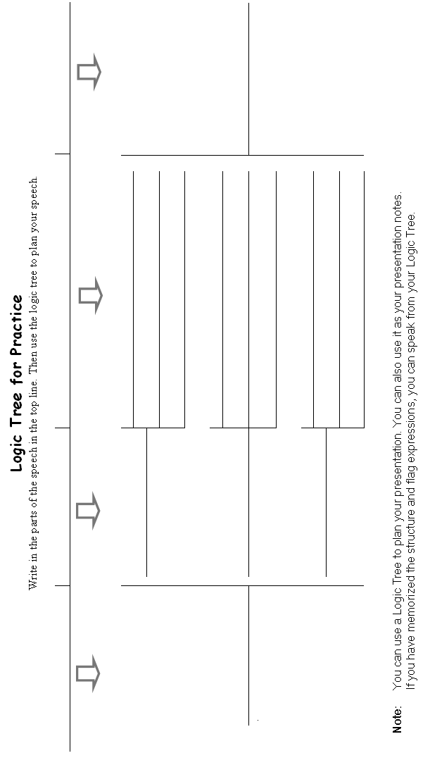

6: Model Speech 2
- Company Introduction
Hiroshi Tanaka had to make a short speech to introduce Nippon Taiyo Bank. He described a little about the history and activities of NTB. Below is his speech.

Notes | Text
1. Introduction  Greetings & courtesies | Good morning everyone. Thank you for inviting me to talk about The Nippon Taiyo Bank. I will tell you a little about Nippon Taiyo’s history and its financial services.
2. Body  Details & examples | The Nippon Taiyo Bank is a large integrated bank based in Tokyo. It was created in 2004 with the merger of two banks. The two banks were the Marunouchi Bank and the Musashi Bank. The Marunouchi Bank was a mid-sized domestic retail bank which focused on providing banking services to individual customers and small businesses. The Musashi Bank was a large corporate bank which provided financial services to mid-sized and large corporate clients domestically and internationally.
The Nippon Taiyo Bank is a well-capitalized institution with retail and corporate branches throughout the country. Currently, we have 257 branches providing a full range of financial services to individuals as well as small and medium sized businesses. Our large corporate clients are taken care of by our head office and our four regional offices. In addition, Nippon Taiyo has seven overseas branches in Asia, North America, and Europe providing financial and investment services to our corporate clients.
NTB’s corporate clients come from all sectors of the economy. Our traditional strength has been providing asset finance, project finance and M&A advisory services to the manufacturing and heavy industry sectors however, in recent years we have also been growing in the IT, communication, and service sectors.
Concluding comments | The Nippon Taiyo Bank is a dynamic bank that cares for domestic needs and has an eye on future opportunities.  I hope this brief introduction has helped you to understand the business of Nippon Taiyo Bank, one of Japan’s major integrated banks.
3. Conclusion  Closing courtesies | Thank you very much for listening.
- Exercise
Use the model above to write an introduction of your company. Write your speech on the next page or write it on your computer and print it out. (Length: 90 seconds)

- Your Company Introduction

7: Quick Speech
- How to prepare a speech by the clock.
1. Decide Topics (3 minutes) | Time
- Brainstorm Topics  Have all the students brainstorm speech topics and write one topic on a piece of paper. | 1 min.
- Check  Collect and check the topics and make corrections if necessary. | 1 min.
- Draw  Each student draws a topic at random - (not their own topic). | 1 min.

2. Prepare & Practice (10 minutes) | Time
- Brainstorm  The students brainstorm their topics and write their notes with coaching. | 2 min.
- Organize with a Logic Tree  The students organize their brainstorming notes into a logic tree. | 3 min.
- Practice  The students stand to review and practice their presentation. | 5 min.

3. Set Up (2 minutes) | Time
- Presentation Set-up  The students write their names on the speech topic sheets. The instructor collects them.  - The students put their speech notes away while they listen to each presentation and take notes. | 1 min.
- Chairing  The first chairperson volunteers, draws a topic at random, and introduces the first speaker.  Note: The first speaker becomes the second chairperson. The first chair is the last speaker. | 1 min.

4. Present (+/- 15 minutes) | Time
Presentation (suggested times)  - Present speech from a logic tree 3 min  (Time alert at 2 min 45 sec.)  - Question preparation 1 min  - Answer questions 5 min  - Feedback 5 min  - Chairing - Introductions and Closing 1 min | 15 min.  /student

8: Language for Chairing
- How to introduce the speaker
Practice the expressions below and then introduce a speaker.

- Chairperson: Introducing the speaker
Good afternoon, everyone. It’s my pleasure to introduce our first / next / last speaker.
His/Her name is ___________ _______________.
Please give M _______________ a warm welcome.
M _______________, if you please.

- Speaker: Before speaking
Thank you for the introduction, M _______________. Good afternoon everyone.

- Chairperson: After the presentation
Thank you M _______________. That was very interesting. / Thank you for your interesting speech M _______________.
Now we have time for some questions.
- We have time for one more question.
- I’m sorry that’s all the time we have for questions.
- If there are no more questions we will close the discussion.
Thank you for your questions everyone. And thank you again, M _______________, for your interesting presentation.

- Chairperson: Asking the instructor for feedback
Now I’d like to ask M (Teacher’s name) for some feedback. M _______________, if you please.
Thank you M _______________. That was very useful feedback.

- Chairperson: Transferring to the next chair
Now, I would like to ask M _______________ to introduce the next speaker. M _______________, if you please.

- The Last Chairperson: Closing the session
And that concludes our presentations. Thank you everyone.



Business Presentations: Essentials
Prepared by David Dobson, Kenneth Goldstone & Tomoko Takahashi
With the assistance of B. Allan & T. Torii

March 2014
Revised July & October 2014, March 2015 & March 2016.

January 2017

Avanti Staff, Language Service Dept.
Tokyo, Japan


